

|  |  |
| --- | --- |
| **Hands-on Exercise No. 3**  **DigiSkills**  **2.0 Batch-05 Wordpress** | **Total Marks: 10**  **Due Date: 31/08/2023** |

**STUDENT NAME**

**Uzma Ejaz**

**Problem Statement:**

**1. Install and activate any E-Commerce theme from the ‘Add Themes’ interface by searching the**

**Install any E-Commerce Theme**

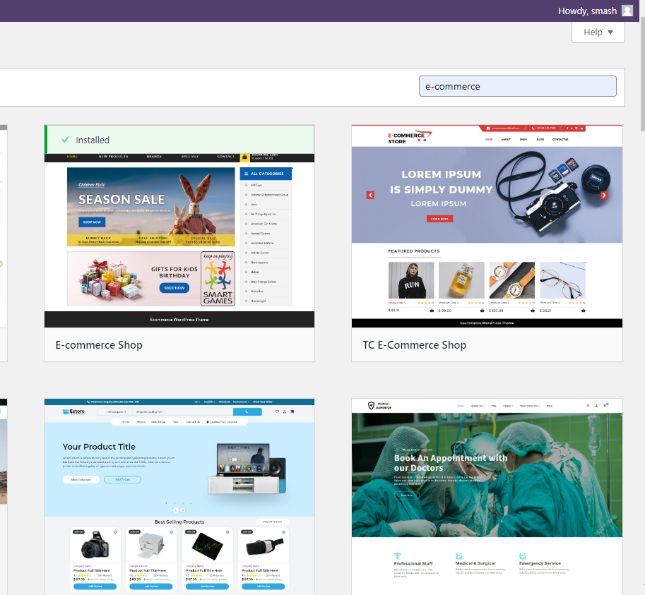

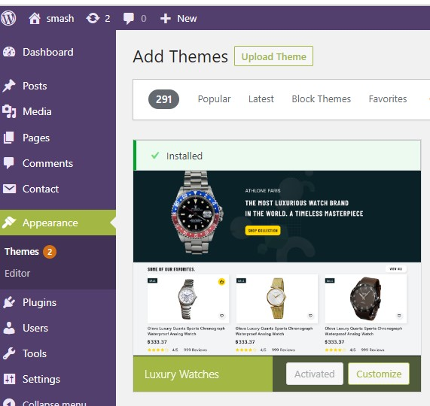



**2. Install and activate the WooCommerce Plugin.**

**Install the WooCommerce Plugin**

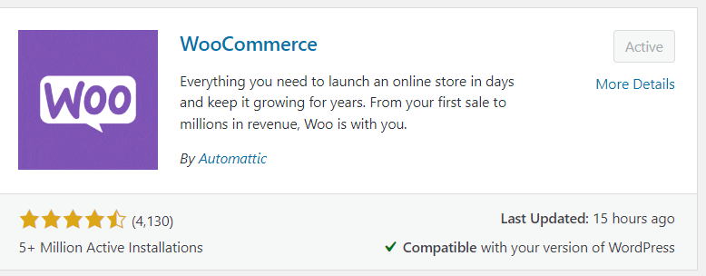

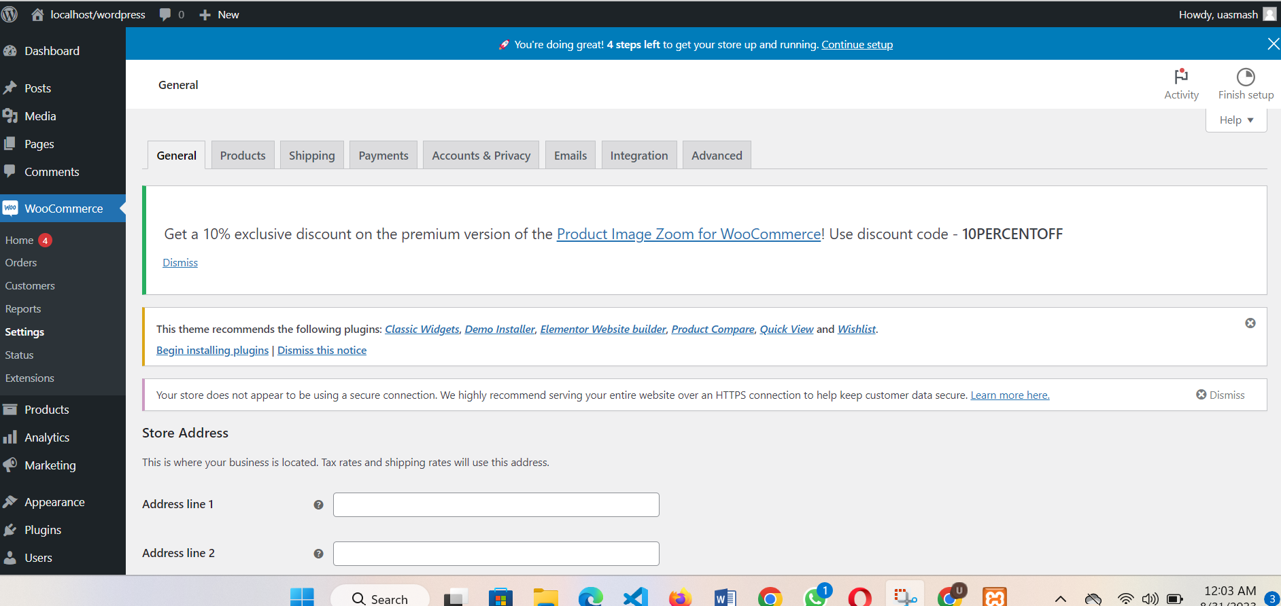

**3. Add 2 products of your choice**

**Product 1:**

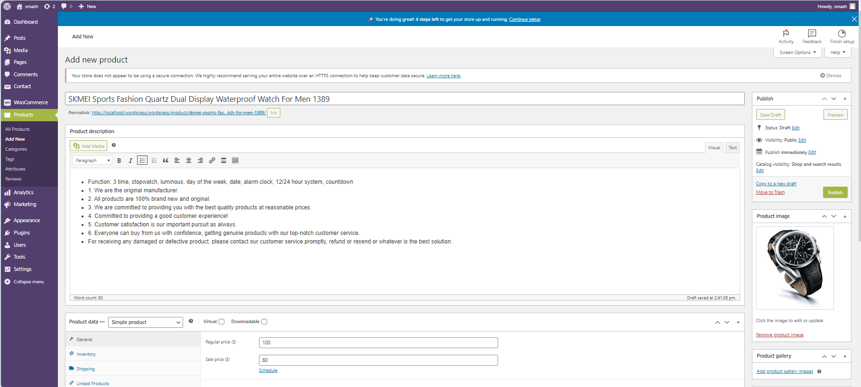

**View on the site:**

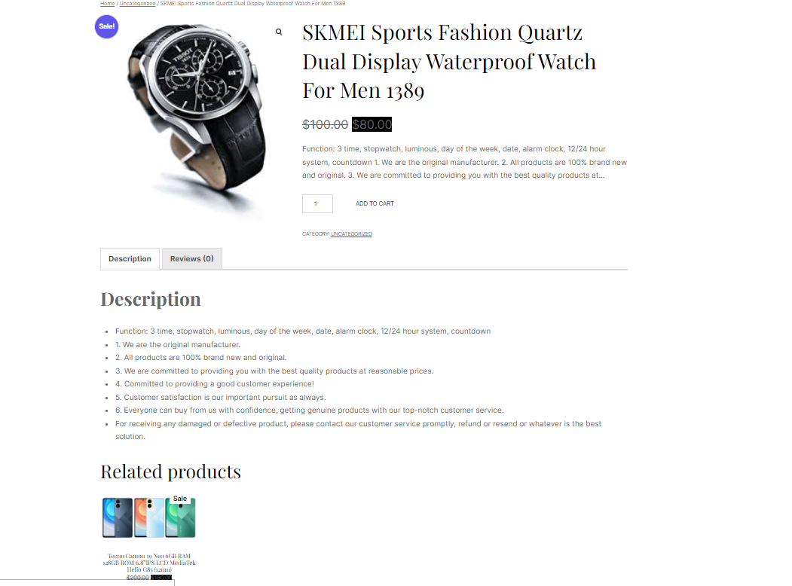

**Product 2:**

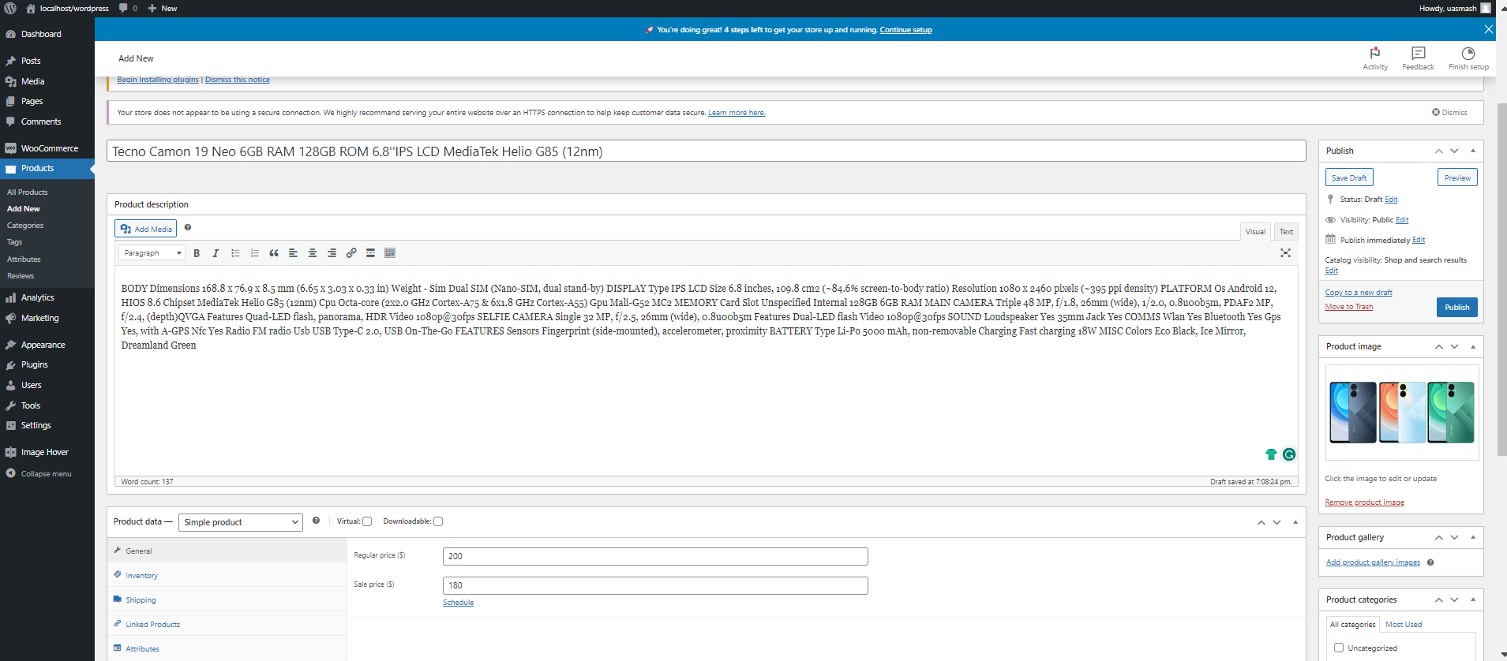

**View on the website:**

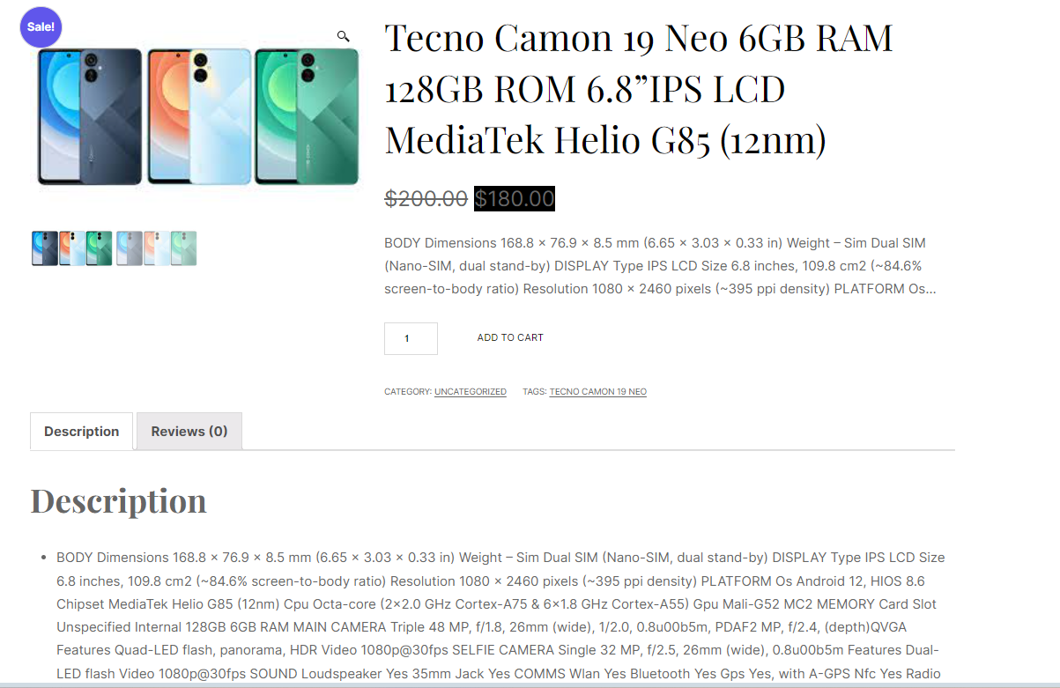

**4.Install WooCommerce Zoom Magnifier plugin and apply to the products.**

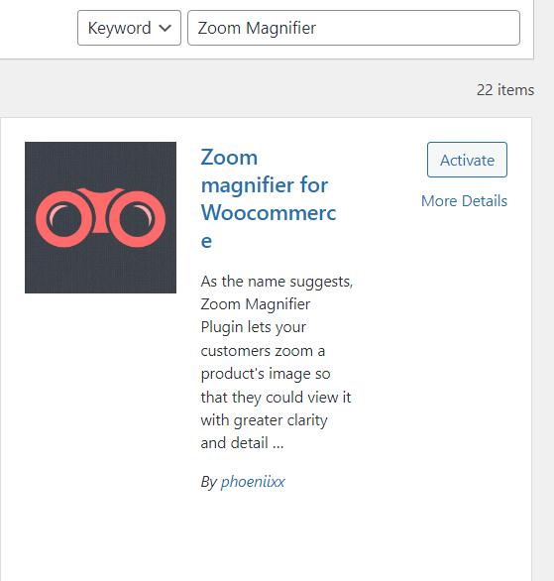

**Apply Zoom Magnifier plugin for 1st product:**

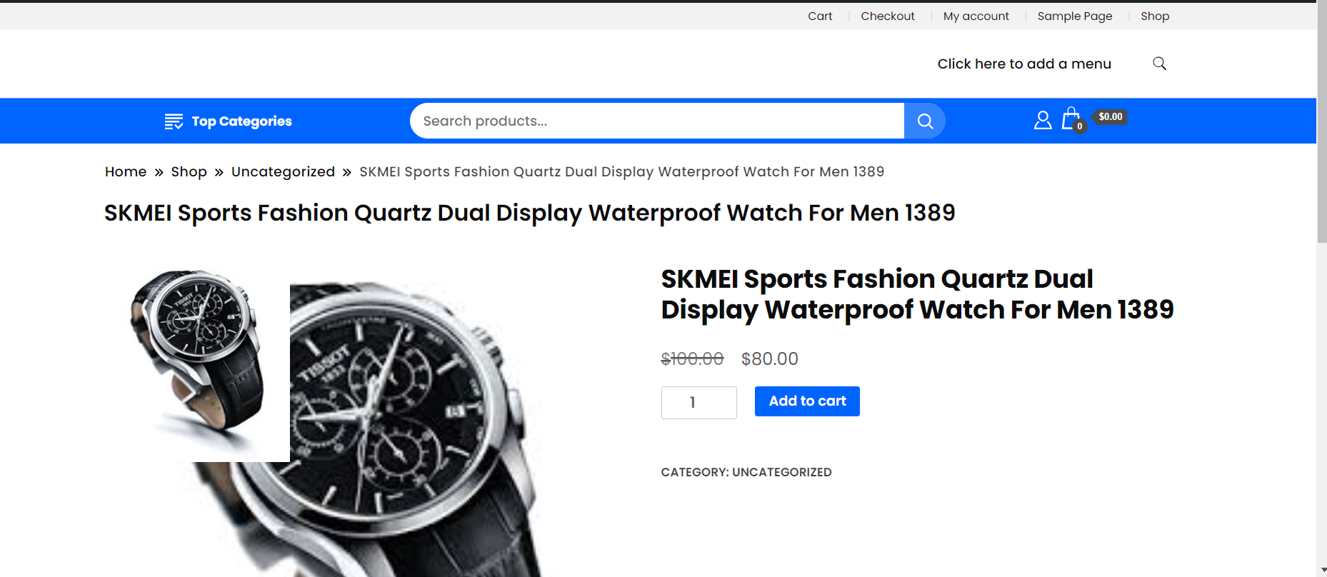

**Apply Zoom Magnifier plugin for 2ndproduct:**

